Test Design & Development

🔹 Definition
# Source: Chatgpt (GPT-5-Standard) at [8/18/2025]
Test Design & Development is the phase in the software testing lifecycle where testers:
- Translate test objectives (from test planning and requirements)
- Into specific test cases, test data, and test scripts that can be executed.
It ensures that tests are structured, systematic, and traceable to requirements.

🛠️ 1. Test Design
# Source: Chatgpt (GPT-5-Standard) at [8/18/2025]
Test design is about deciding what to test and how to test it.
- Inputs: Test plan, requirements, risk analysis, architecture/design docs.
- Activities:
  - Identify test conditions (what features/behaviors to test).
  - Derive test cases (steps, inputs, expected results).
  - Design test data (valid, invalid, boundary values).
  - Ensure coverage of requirements, risks, and acceptance criteria.
- Techniques used:
  - Black-box (equivalence partitioning, boundary value analysis, decision tables, use cases).
  - White-box (path testing, branch coverage).
  - Experience-based (error guessing, exploratory).
Example:
For a login page:
- Test condition: User authentication.
- Test cases:
  - Valid username + valid password → login success.
  - Valid username + invalid password → error.
  - Blank fields → validation message.
- Test data: Usernames, passwords, invalid credentials.

🛠️ 2. Test Development
# Source: Chatgpt (GPT-5-Standard) at [8/18/2025]
Test development is about building the tests so they can be run.
- Activities:
  - Write manual test cases (detailed steps).
  - Create automated test scripts (using Selenium, Cypress, JUnit, etc.).
  - Organize test cases into test suites.
  - Prepare test environment setup instructions.
  - Document traceability between requirements → test cases.
Example:
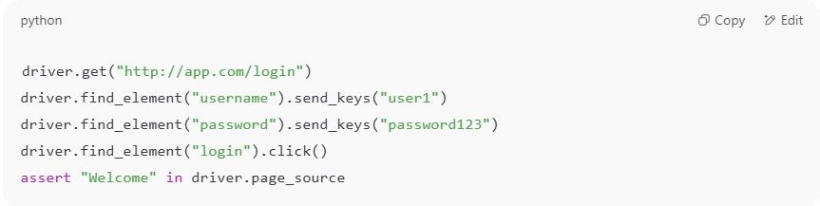
Develop an automated script for login test using Selenium:
driver.get("http://app.com/login")
driver.find_element("username").send_keys("user1")
driver.find_element("password").send_keys("password123")
driver.find_element("login").click()
assert "Welcome" in driver.page_source

📌 Outputs of Test Design & Development
# Source: Chatgpt (GPT-5-Standard) at [8/18/2025]
- Test cases (manual/automated).
- Test data sets.
- Test scripts / test automation code.
- Test suites (group of related tests).
- Requirement traceability matrix (RTM).

🔑 Importance
# Source: Chatgpt (GPT-5-Standard) at [8/18/2025]
- Ensures coverage of requirements & risks.
- Reduces chance of missing defects.
- Provides clear, repeatable tests for execution.
- Serves as documentation for stakeholders.

✅ In short:
- Test Design = figuring out what and how to test (conditions, cases, data).
- Test Development = actually creating the detailed test cases and scripts.

